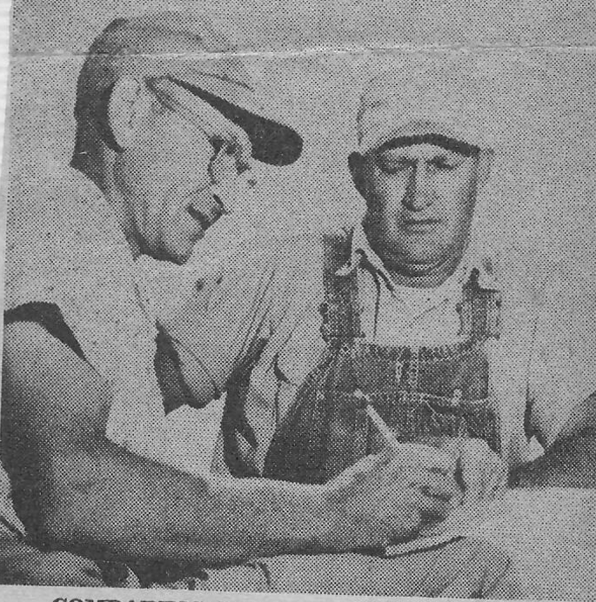  COMPARING CROP progress reports are Robert Basinger (left), federal work unit conservationist for the Wayne County Soil Conservation District, and Harry A. Blackford, who farms some 440 acres southwest of Fairfield. Blackford has knee-high corn on land that seven weeks ago was under water. He expects to average 90 bushels of corn an acre on the land. | 